SOLID Principles in Java
SOLID is a set of five object-oriented design principles used to create clean, maintainable, scalable, and flexible software. These principles are guidelines that help developers design better classes and relationships between classes.
→ Makes code easier to understand
→ Helps modify code safely
→ Improves reusability
→ Makes testing easier
→ Reduces dependencies between classes
→ Supports large applications and team development
1. Single Responsibility Principle (SRP)
Definition: A class should have only one responsibility and one reason to change.
One class should do one job only.
Why Use It: If one class does multiple jobs, changing one feature may affect another.
Benefits
→ Easy maintenance
→ Easy testing
→ Better readability
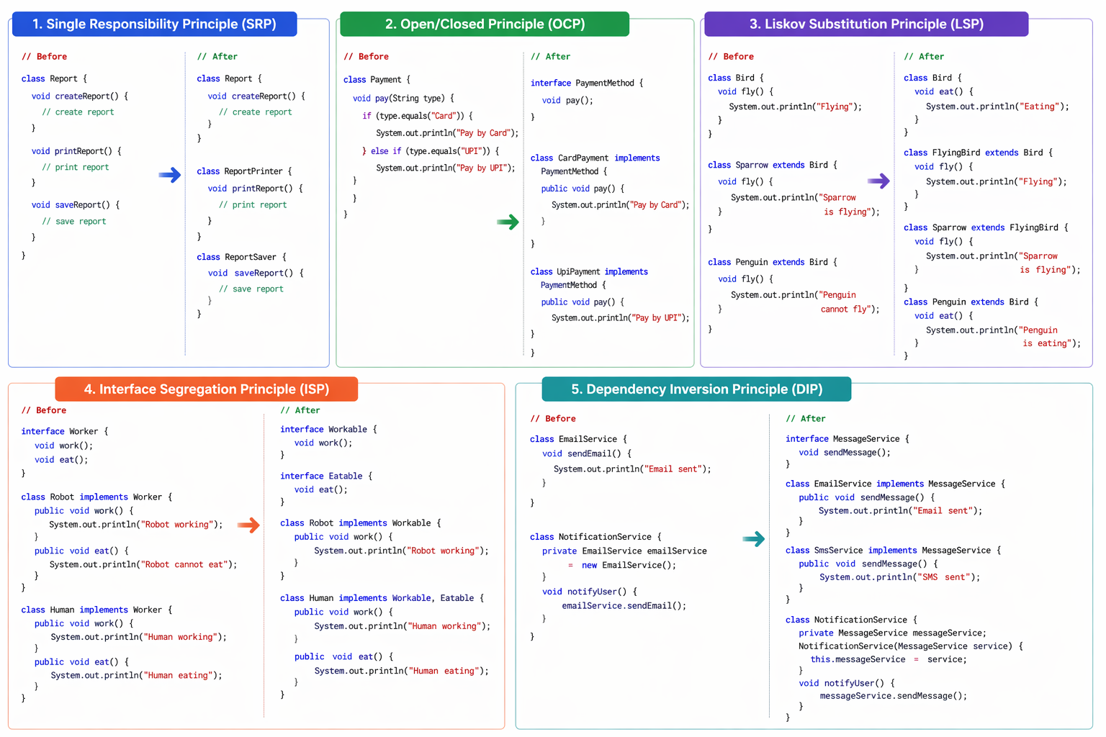
2. Open/Closed Principle (OCP): Software entities should be open for extension but closed for modification.
New features should be added by extending code, not by repeatedly changing old code.
Why Use It: Changing tested code again increases bug risk.
Benefits
→ Easy feature addition
→ Safer code changes
→ Better scalability
Extend behaviour don’t modify old code


3. Liskov Substitution Principle (LSP)
A subclass should be able to replace its parent class without breaking program behaviour.
If child extends parent, child object should work wherever parent is expected.
Why Use It: Prevents wrong inheritance design.
Benefits
→ Correct inheritance
→ Better polymorphism
→ Fewer runtime issues


4. Interface Segregation Principle (ISP)
A class should not be forced to implement methods it does not use.
Use small, focused interfaces instead of one large interface.
Why Use It: Large interfaces create unnecessary methods and dummy implementations.
→ Robot implements Workable
→ Human implements both


5. Dependency Inversion Principle (DIP)
High-level modules should depend on abstractions, not concrete classes.
Classes should depend on interfaces instead of directly depending on implementation classes.
Why Use It: Reduces tight coupling and allows easy replacement of services.
Benefits
→ Loose coupling
→ Easy testing
→ Replace implementations easily


